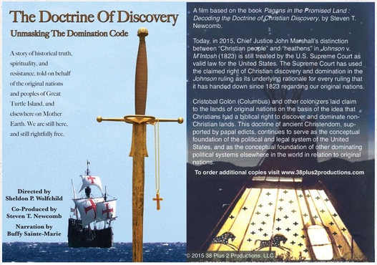
38 PLUS 2 PRODUCTIONS
Directed by Sheldon Wolfchild (Dakota)

An online Screening hosted by Learning Right Relations

THE DOCTRINE OF DISCOVERY
Unmasking the Domination Code

Sunday, June 3, 2020 / Time: 1:00 – 3+ pm
Online Screening via Zoom - Registration

This hour-long film and production by First Nation Peoples examines the effects of an ancient doctrine
traced to Vatican Papal Orders (Bulls) issued by Popes in the Fifteenth century which purported to
grant rights to claim domination, in perpetuity, over non-Christian lands and their inhabitants.

Presentation & Conversation with Deb Cruz and Jonathan Neufeld
Washington State leaders working on dismantling the Doctrine of Discovery and
other Issues facing American Indians.
More information about the film
38plus2Productions.com
More information about online events
learningrightrelations@gmail.com

